Md Shahrukh Khan Sohel

Roll: 2007084

Department of CSE, KUET

CSE 3110 Oracle SQL Database Project

**Art Work Management Project**

**Introduction**

➢ Project Overview

It is an Art Work Management system that offers detailed data on Artist, Artworks, Customers.

It aims to provide a centralized platform for fans, analysts to access information about Art Work, using a robust Oracle SQL database.

**Project Objectives**

➢ To Implement SQL Queries for Retrieving, Updating, and Managing Data

within the Database

A crucial objective of this project is to implement a wide range of SQL queries that allow for the

manipulation and retrieval of data stored within the database. These queries enable various functionalities,

such as adding new records, updating existing information, and retrieving detailed data based on specific

criteria.

**Database Design**

➢ Overview of the Database Schema

The database is structured around several key tables designed to encompass all necessary Art Work

related data. The main tables include:

1. Artist: Contains information about the artist such as : name, birthplace , address , style of art etc.
2. Art Work: Keeps track of the artist who produced the art work by referencing the artist table by a foreign key. Stores information about approximate price , day it was exhibited , type and many more.
3. Customer: Specifies the name of the customer who bought a art work and their name , address , phone number etc.

➢ Table Relationships

The relationships between the tables are primarily defined by foreign keys that ensure data integrity and

relational connections.

➢ Relational Database Schema

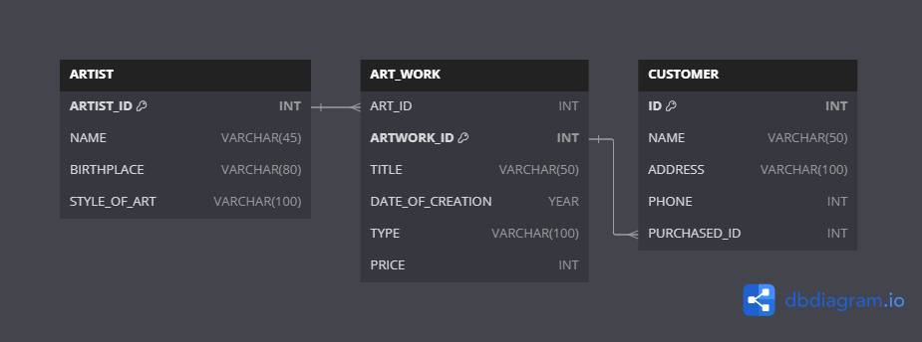

**SQL Queries and Functionality**

To facilitate a wide range of informational needs for users, several SQL queries have been designed to

extract useful information from the database. Advanced SQL features such as stored procedures, triggers, and functions are extensively utilized to enhance the functionality and efficiency of the database.

**Conclusion**

Throughout the development of the database, numerous achievements were realized, such as overcoming

mastering complex SQL functionalities and integrating advanced database management techniques.

However, the project also faced challenges, such as errors encountered during the execution of SQL queries.